This approach considers items to put in bags progressively as the capacity of the bag is broken into sub-capacity. Updating the value in the cell of matrix by comparing it’s value to the value in the cell of the same column but the row before (i-1).

Take trial dataset as an example, there are 4 items and the maximum capacity is 10, therefore, we have a value matrix of 11 columns including the 0-th column, and 4 rows.

In the first row we only consider the situation where taking item 1, the cell records the value when the capacity is greater or equal to the weight. The second row item 1 and 2 are both considered, for the cell with capacity greater than item 1 but not item 2 it takes the value of item 1. In cell (1,10) we can take both item 1 and item 2 to maximize the capacity and have a greater value than (0,10) therefore we update it to 21.

For the final cell (3,10), item 4 is taken with value of 10, remaining capacity is 10-4 = 6, and (3,6) has value of 12 therefore the value in the last column in last row can be updated from 21 to 10+12=22.

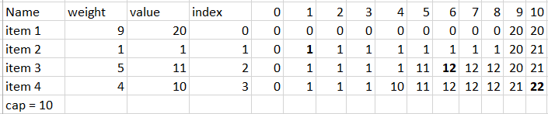

This approach is called a bottom-up approach.